SPRINT DELIVERY 2

TEAM ID : PNT2022TMID19437

**PROJECT NAME : PERSONAL ASSISTANCE FOR SENIORS WHO ARE SELF RELIANT**

**CONTENTS:**

# DASHBOARD

1. **ADD MEDICINE**
2. **ADD PRESCRIPTION**
3. **NOTIFICATIONS**
4. **SCHEDULE**
5. **MEDICINES**
6. **PRESCRIPTIONS**
7. **DASHBOARD**

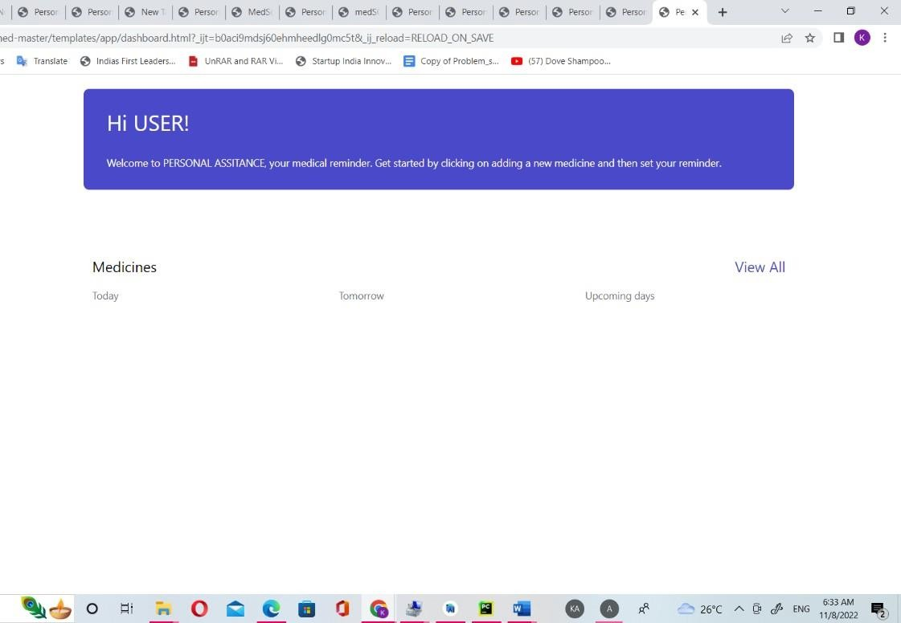

1. **ADD MEDICINE**

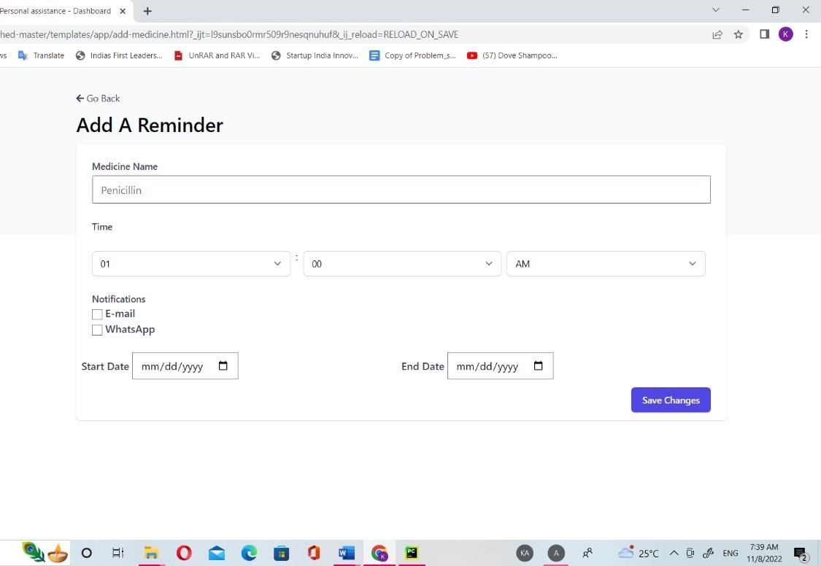

1. ADD PRESCRIPTION

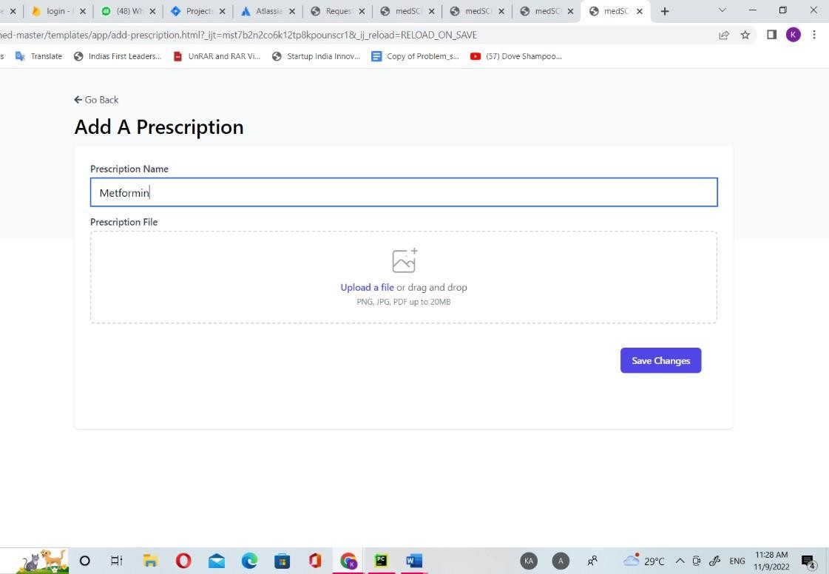

1. SCHEDULE

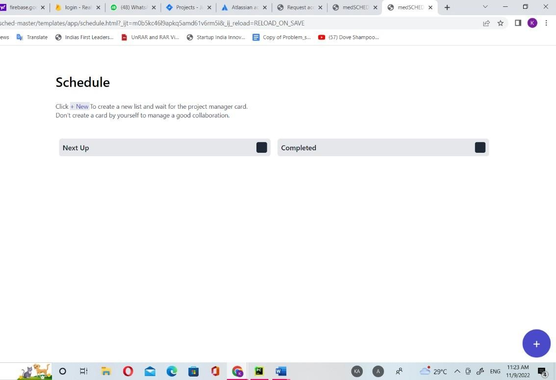

1. MEDICINES

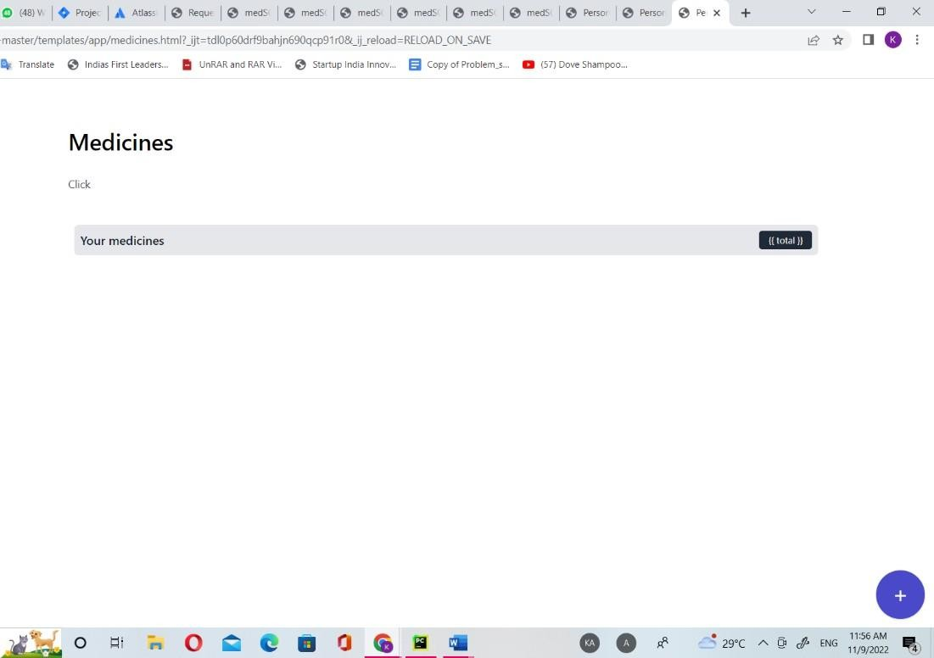

1. PRESCRIPTIONS

